12 May 2017

USA retail sales
Retail sales %m/m -3mma
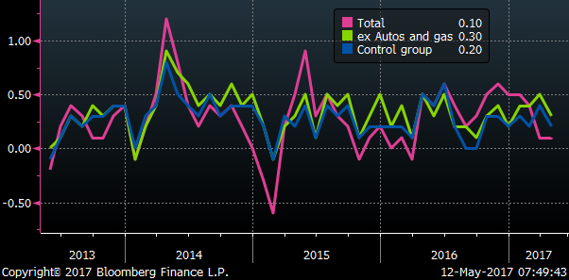
Retail sales %y/y
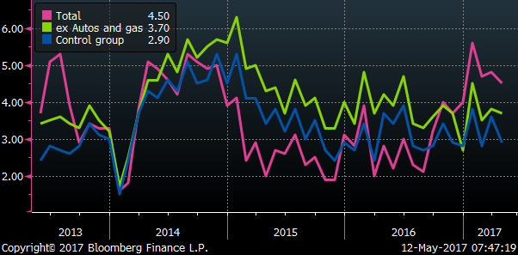

Retail sales total rising at a slow 0.1%m/m pace in the last three months, weak autos component, down from a strong 0.5%m/m-3mma in Q4 last year. Up a moderate 4.5%y/y
Ex-autos and gas, rising at a moderate 0.3%m/m pace. Up a moderate 3.7%y/y
Control group (less food, autos, gas and building materials) rising at a modest 0.2%m/m-3mma pace. (Building materials helping support overall sales). Up a modest 2.9%y/y

US core CPI up 1.88%y/y in April, down from 2.00%y/y in Mar and 2.22% in Feb
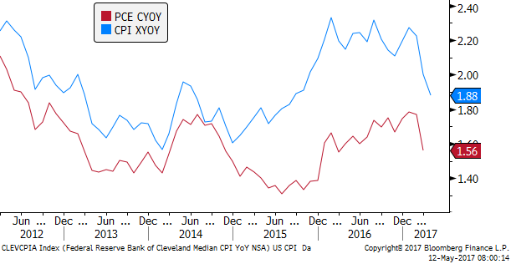

The fall in US core narrows the gap with the rise in Eurozone core in April
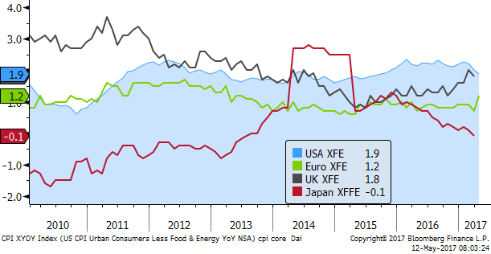

US University of Michigan consumer confidence remained high – firmed a bit from April.
High consumer confidence is at odds with the modest to moderate pace of retail sales
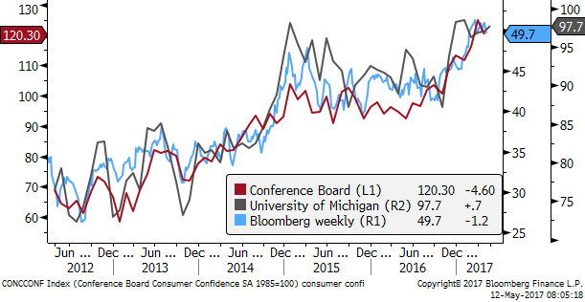

University of Michigan long-term inflation expectations fell to 2.3%, revisiting the record low in December last year. They now match market-based long-term inflation compensation in the swaps market, which has drifted down modestly this year after rising significantly in Q4 last year.
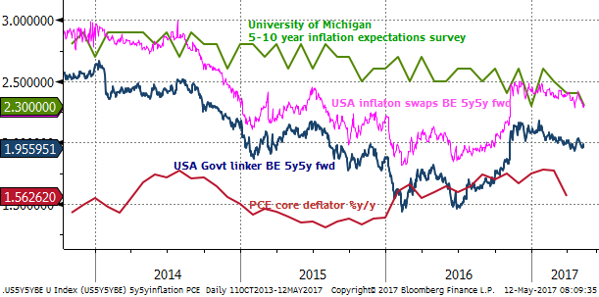

The US data this week has undermined the USD, lower inflation, and weaker retail sales, seeing a significant fall in US bond yields. (now down 5.3bp) on lows for the day.
AUD and NZD may now be paying more attention to bond yields, with the impact on bank funding costs and search for yield trades playing a bigger role.
Developed market equities have stalled this week in a low vol environment, but emerging market equities have risen strongly, consistent with a view expressed by some commentators that are advising rotation away from US equities to emerging markets.
Chinese equities have recovered this week, supporting this move. Chinese money market rates have eased, suggesting authorities are moving to ease policy a bit to help stabilized asset markets. However, Chinese corporate bond yields remained high or edged higher, widening yield spreads.
Iron ore prices remained hemmed at recent lows; oil prices recovered somewhat from early in the week.
Overall market vol remains low. It is fell further for currencies and bonds. The dollar is broadly weaker this week against majors, emerging and commodity currencies – the main exception is NZD on dovish RBNZ and CAD is weaker on bank downgrades.
We cannot be confident that our short trades in AUD and NZD will perform next week with US yields softer and data underwhelming. The Comey affair will continue to bubble, but may remain more background noise. It is diminishing hopes of tax reform, so much depends on current momentum in the US economy.
If China is now acting to support its asset markets, this will tend to support AUD. But the lack of bounce in iron ore is preventing it from recovering much yet.
Next week, home loan data may be weak and undermine AUD. Consumer confidence may be soft (weak bank stocks). Although govt budget may more broadly be seen as supportive for confidence with bigger infrastructure spending. Some other factors less supportive (education and Medicare costs).
The Australian wages data are quite important, any sign of improvement would tend to support AUD as low incomes are a major policy issue. The employment data are of course important. Recent job ads and business confidence surveys suggest this may be supportive.
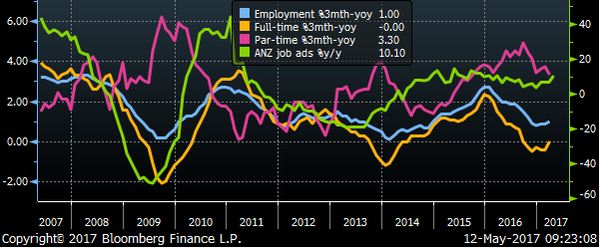
In the US, housing data and some manufacturing surveys may tend to give stronger outcomes for the USA.
CPI data in Canada will be interesting after recent weak outcomes. UK CPI is due
Chinese economic reports early next week may be a bit weaker, this is expected, probably of little consequence.
Eurozone GDP Q1, likely to be strong, may keep EUR bid, with gains this week setting its lower end of the range.

10-year govt bond yields fall in USA 5.8bp on Friday (so far), down 6.4bp from a peak on Wednesday
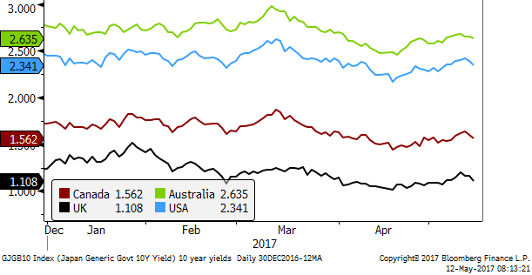
2yr-swap rates in the USA down 4.0bp on Friday, down 7bp from a peak on Monday
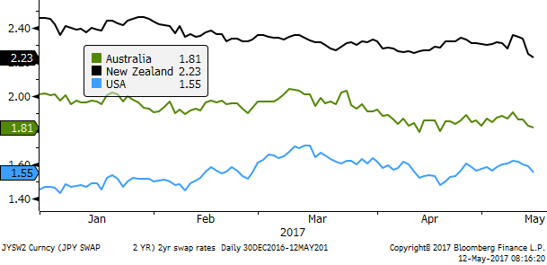

US equities very low vol, edged down from peak on Wednesday – Australian equities underperforming in recent weeks
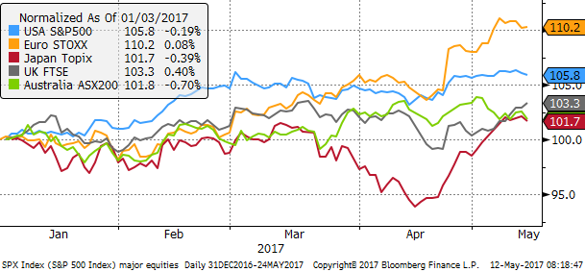

Equity and bond market vol – bond vol at a low since 2014, equity vol firms from lowest on record on Monday
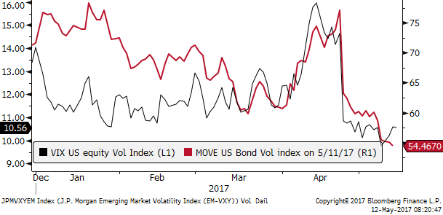

Currency vol at lowest since 2014
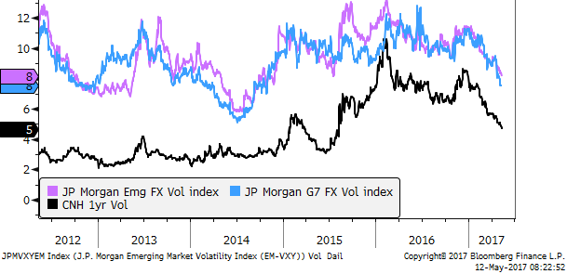

Emerging market bond spread index at a low since 2014; Citibank macro risk index around its lowest on record since 2010
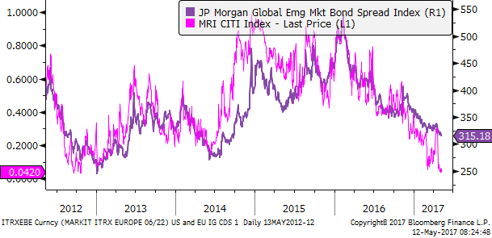

Investment grade corporate bonds credit default swap indices firmed from recent lows in Wednesday. The Eurozone index has closed gap to USA, at lows since 2015.
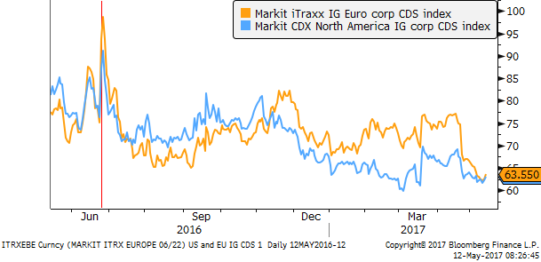
Oil prices firm from lows on Tuesday, iron ore relatively stable at lows this week. Milk futures ease a bit this week, though best performing of this set over recent months.
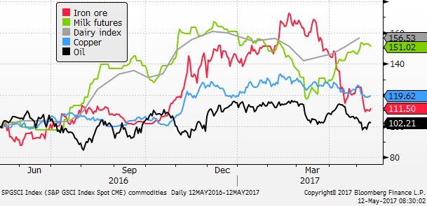

USD loses ground broadly this week, after strong performance in preceding weeks
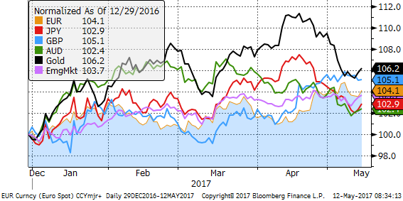

Asian currencies stronger this week, KRW leader after election
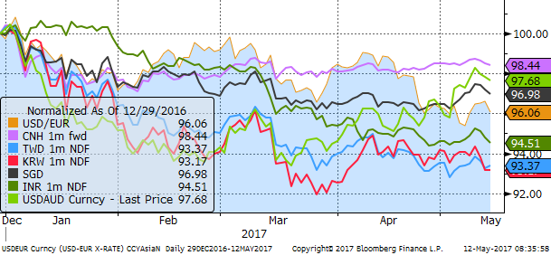

Emerging market equities in Asia and Latam up strongly this week, approaching highs in 2015
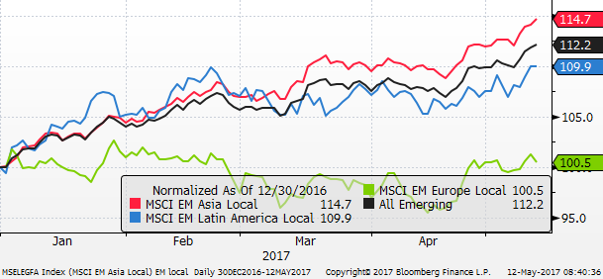
Emerging take lead from developed equities
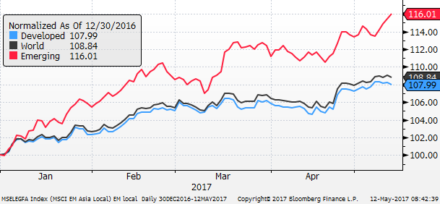

Asian equities – Chinese mainland equites recover this week after a declining in the preceding month. Hong Kong Chinese listed companies rise more strongly, leading gains in Asia in the last week. Korea has been the strongest market over the last month or so, stalling this week in relatively choppy trading. India one of strongest this year, Thailand the weakest
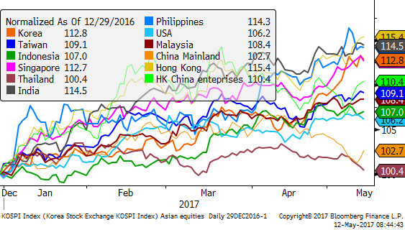
Chinese interest rates ease from peak on Wednesday, in line with US rates
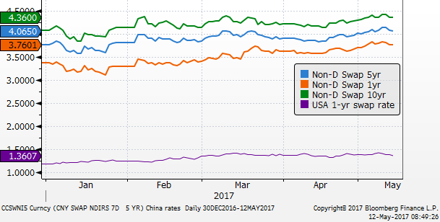

Chinese corporate bond yields stay high this week
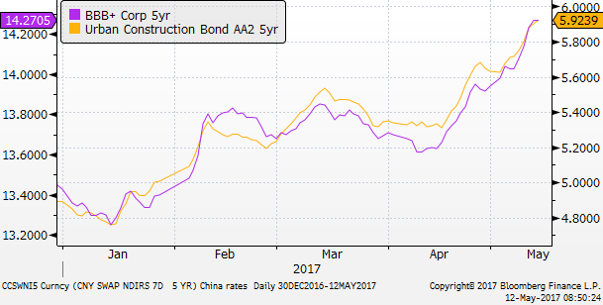
Chinese government bond yield edged down with US bonds – so credit spreads still firming in China
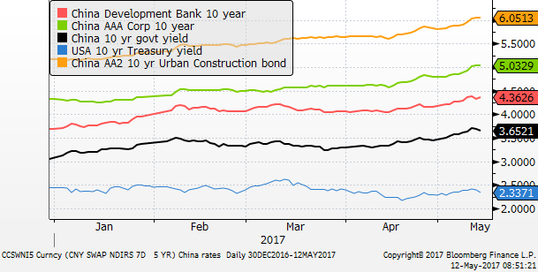

Chinese money market rates fall this week
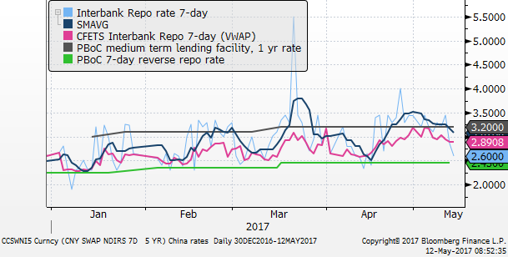

Bank equity indices – Australian banks flat after deep fall on Tuesday (budget levy), down sharply over May. Canada bank shares fall somewhat further towards end week (Moodys downgrade). US banks are weak at end week.
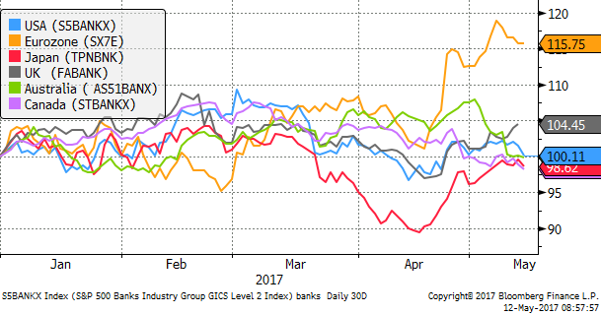

Currencies vs 2yr spreads
